COVID-19

At Enfys Hapus Nursery we promote the good health of all children attending through maintaining high hygiene standards and reducing the chances of COVID-19 being spread. We follow the COVID-19 Infection Prevention and Control for Childcare Settings (0-5 years) Nurseries Child Minders and Playgroups guidance.

COVID-19 can be spread from person to person through:
- Droplets – If an infected person coughs, sneezes, or talks, the droplets fly into the air.
- Aeroslized Transmission – lives in the air for up to 3 hours.
- Surface transmission – live on surfaces like plastic and stainless steel for 2 to 3 days.
- Fecal-oral – through soiling.
- Asymptomatic spread – someone unaware of being infected passing onto others.
- Presymptomatic soread – pass it on before signs of infection.
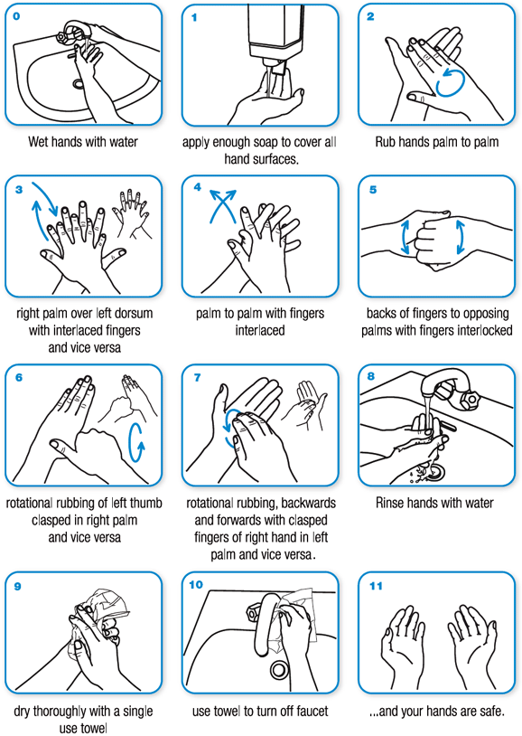
Handwashing and Hand Sanitising
Hand hygiene is essential before and after all direct contact with a child and after cleaning equipment and the environment. It is important for all staff to:
- Wash hands thoroughly for 20 seconds by following example.
- All children are encouraged to wash hands regularly whilst in setting.
- When washing children’s hands they are encouraged to sing ‘Happy Birthday’ twice.
- Handwashing should be done:
  - When arriving at the setting.
  - After use of the toilet.
  - Before and after eating.
  - After returning indoors from outdoor play.
  - After being in physical contact with other children.
  - After sneezing or coughing.
- An alcohol-based hand rub can be used if hands are not visibly dirty or soiled.

This policy was adopted on | Signed on behalf of the nursery | Date for review
17th June 2020 | Paige Webbley | June 2021

